Ideation Phase
Brainstorm & Idea Prioritization
Date | 13 October 2026
Roll Number | 323103282099
Project Name | Incident Lifecycle Automation in ServiceNow
Maximum Marks | 4 Marks

Problem Statement
Most IT teams already have a ticketing tool, but that alone does not make incidents move smoothly. In practice an issue gets logged with half the details missing, it sits in the wrong queue for a while, and when it finally reaches the right person they start from zero because nobody wrote down what was tried. Fixes that worked last month are buried in old tickets, and the SLA clock keeps ticking through all of it.
For this project I wanted to take one real-looking issue, a user who suddenly cannot connect to the Corporate VPN, and walk it through a proper incident lifecycle in ServiceNow from the first phone call to a reusable knowledge article.
I am | I'm trying to | But | Because | Which makes me feel
A Service Desk agent | Resolve user incidents within the SLA | Tickets arrive poorly classified and bounce between teams | There is no standard flow that connects knowledge, change and SLAs | Rushed and unsure whether I will meet the SLA
A Level 2 network technician | Fix infrastructure faults such as a VPN outage | Incidents reach me late and with very little context | The CI, related changes and duplicate reports are not linked | Frustrated by repeated work
An IT manager | See how healthy our services are and whether SLAs are met | Incident, change and SLA data is spread across places | There is no single view of the lifecycle | Unable to show the quality of our service

Empathy Map Canvas
Before listing any ideas I tried to put myself in the shoes of the Service Desk agent, since they are the first person to touch every incident. The map below is what came out of that exercise.
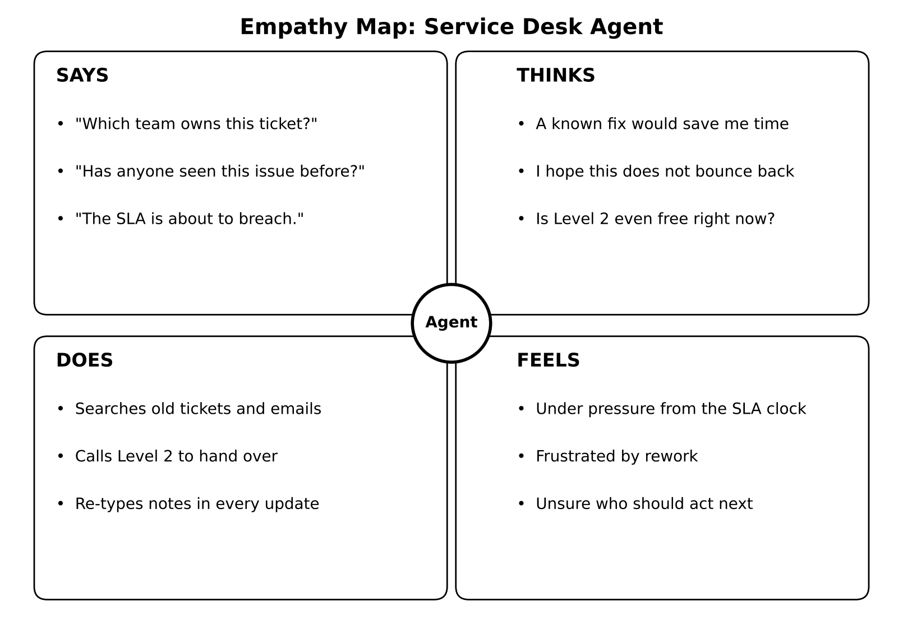
Figure 1: Empathy map for the Service Desk agent

Brainstorm & Idea Prioritization
My approach here was simple: get every idea out first and judge them later. I did it in three steps. First I picked the problem, then I listed and grouped ideas, and finally I decided what to build first.

Step 1: Team Gathering, Collaboration and Selecting the Problem Statement
I started by reading through the project brief and the business objectives, and jotted down every pain point I could think of in day-to-day incident handling. From that list I picked the one that covered the most ground:
Selected problem statement: Incident handling is inconsistent and manual. I want to automate and standardize the full Incident Management lifecycle in ServiceNow so that agents can classify incidents properly, reuse knowledge, escalate cleanly, raise changes when needed, and close the loop with a knowledge article, all while SLAs are tracked.

Step 2: Brainstorm, Idea Listing and Grouping
These are the ideas I listed, grouped by the part of the lifecycle they belong to.
Group | Ideas
Logging and classification | Create incidents in Service Operations Workspace  Capture category, subcategory, urgency, service, service offering and CI  Let priority calculate from impact and urgency
Knowledge | Search articles with Agent Assist  Attach the useful article and mark it helpful  Create a new article from the final resolution
Escalation and collaboration | Use assignment groups (Service Desk, Network)  Use "Assign to me" for clear ownership  Add a watch list and work notes list
Change | Raise an emergency change for the fix  Put the incident On Hold with reason "Awaiting Change"
Recurring issues | Log repeat reports as child incidents  Let child incidents resolve with the parent
Visibility | Track response and resolution SLAs  Build an "Incidents by Priority" report

Step 3: Idea Prioritization
I placed each idea on an impact versus effort grid. Anything high impact and low effort became a quick win and went into the first sprints. The bigger pieces, like the emergency change and child incidents, came after the basics were working.
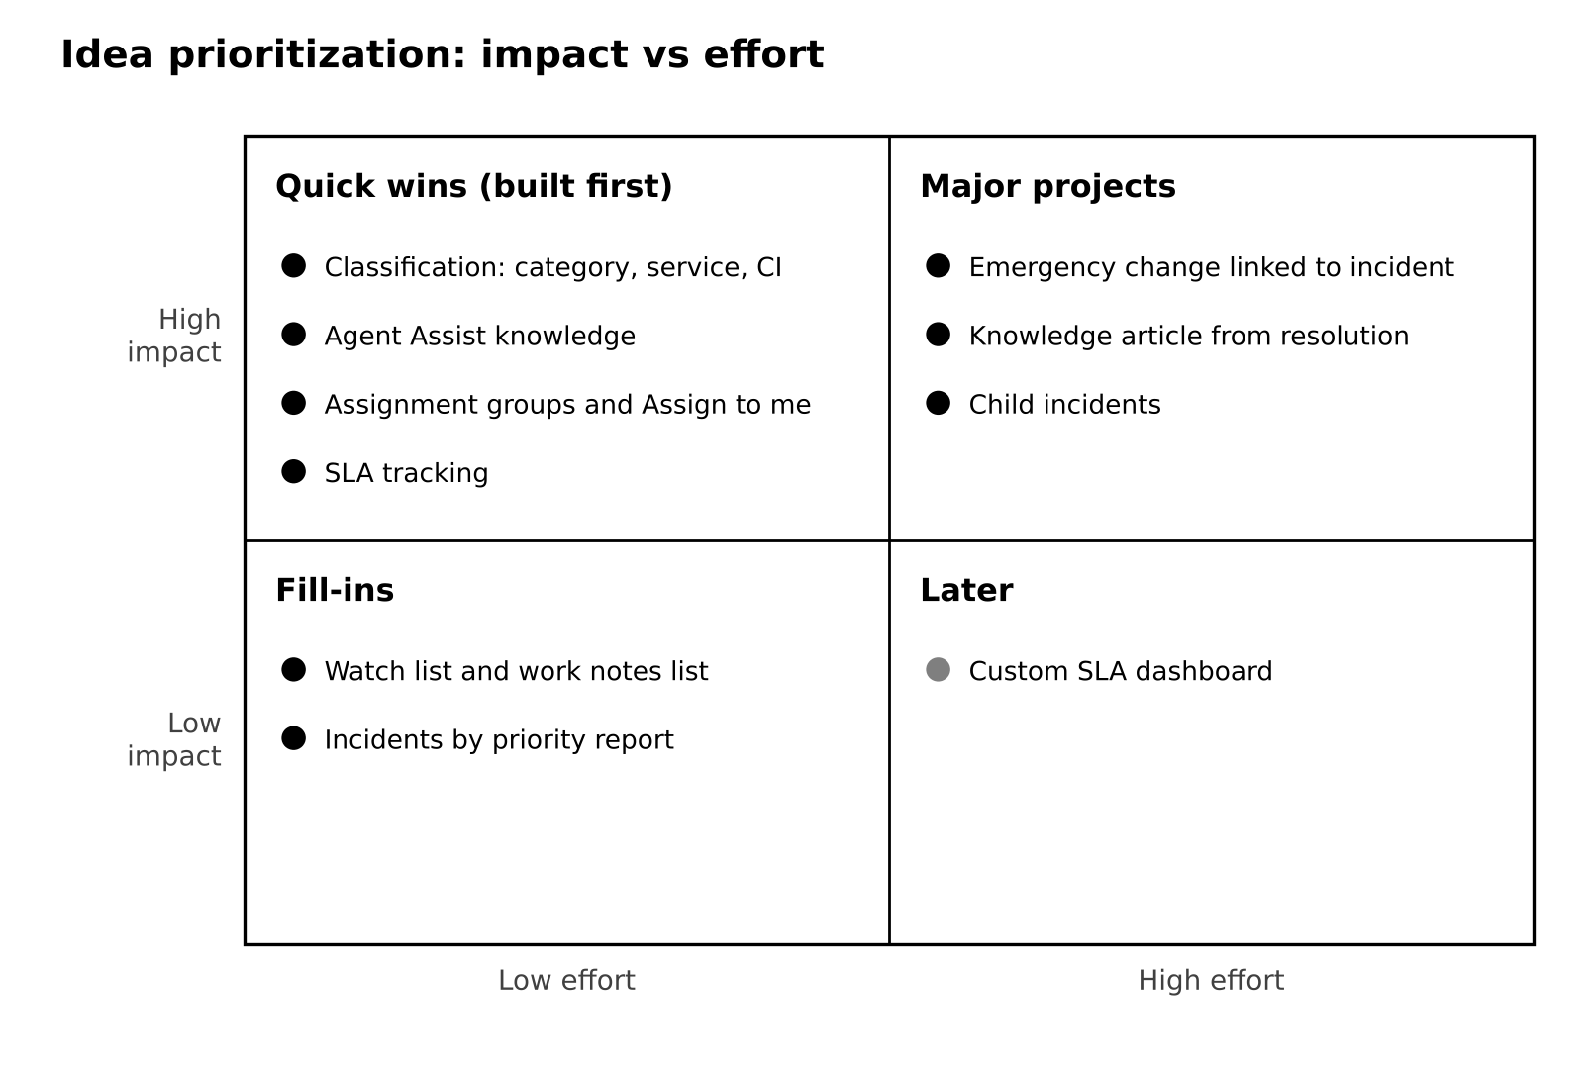
Figure 2: Idea prioritization grid
- Quick wins: classification, Agent Assist knowledge, assignment groups and SLA tracking.
- Major projects: emergency change, knowledge from resolution and child incidents.
- Fill-ins: watch list, work notes list and a simple report.
- Later: a custom SLA dashboard, which I kept as future scope.

